|  |  |  |  |
| --- | --- | --- | --- |
|  | **Growth of epitaxial orthorhombic YO1.5-substituted HfO2 thin film** | | |
|  | Cite as: Appl. Phys. Lett. **107**, 032910 (2015); <https://doi.org/10.1063/1.4927450>Submitted: 24 May 2015 . Accepted: 12 July 2015 . Published Online: 24 July 2015 | | |
|  | [Takao Shimizu](https://aip.scitation.org/author/Shimizu%2C+Takao), [Kiliha Katayama](https://aip.scitation.org/author/Katayama%2C+Kiliha), [Takanori Kiguchi](https://aip.scitation.org/author/Kiguchi%2C+Takanori), [Akihiro Akama](https://aip.scitation.org/author/Akama%2C+Akihiro), [Toyohiko J. Konno](https://aip.scitation.org/author/Konno%2C+Toyohiko+J), and [Hiroshi Funakubo](https://aip.scitation.org/author/Funakubo%2C+Hiroshi) | | |
|  |  |  |  |
|  | **ARTICLES YOU MAY BE INTERESTED IN**  [Ferroelectricity in hafnium oxide thin films](https://aip.scitation.org/doi/10.1063/1.3634052)  Applied Physics Letters **99**, 102903 (2011); <https://doi.org/10.1063/1.3634052>  [On the structural origins of ferroelectricity in HfO2 thin films](https://aip.scitation.org/doi/10.1063/1.4919135)  Applied Physics Letters **106**, 162905 (2015); <https://doi.org/10.1063/1.4919135>  [Stabilizing the ferroelectric phase in doped hafnium oxide](https://aip.scitation.org/doi/10.1063/1.4927805)  Journal of Applied Physics **118**, 072006 (2015); <https://doi.org/10.1063/1.4927805> | | |
| Appl. Phys. Lett. **107**, 032910 (2015); <https://doi.org/10.1063/1.4927450> | **107**, 032910 | |
| © 2015 AIP Publishing LLC. | | |

APPLIED PHYSICS LETTERS 107, 032910 (2015) 

[Growth of epitaxial orthorhombic YO1.5-substituted HfO2 thin film](http://dx.doi.org/10.1063/1.4927450)

Takao Shimizu,1Kiliha Katayama,2Takanori Kiguchi,3Akihiro Akama,3Toyohiko J. Konno,3 and Hiroshi Funakubo1,2,a)   
1Materials Research Center for Element Strategy, Tokyo Institute of Technology, 4259 Nagatsuta, Midrori-ku, Yokohama 226-8503, Japan   
2Department of Innovative and Engineered Materials, Tokyo Institute of Technology, 4259 Nagatsuta, Midrori-ku, Yokohama 226-8502, Japan   
3Institute for Materials Research, Tohoku University, 2-1-1 Katahira, Aoba-ku, Sendai 980-8577, Japan

(Received 24 May 2015; accepted 12 July 2015; published online 24 July 2015)

YO1.5-substituted HfO2 thin films with various substitution amounts were grown on (100) YSZ substrates by the pulsed laser deposition method directly from the vapor phase. The epitaxial growth of film with different YO1.5 amounts was confirmed by the X-ray diffraction method. Wide-area reciprocal lattice mapping measurements were performed to clarify the crystal symme-try of films. The formed phases changed from low-symmetry monoclinic baddeleyite to high-symmetry tetragonal/cubic fluorite phases through an orthorhombic phase as the YO1.5 amount increased from 0 to 0.15. The additional annular bright-field scanning transmission electron micros-copy indicates that the orthorhombic phase has polar structure. This means that the direct growth by vapor is of polar orthorhombic HfO2-based film. Moreover, high-temperature X-ray diffraction measurements showed that the film with a YO1.5 amount of 0.07 with orthorhombic structure at room temperature only exhibited a structural phase transition to tetragonal phase above 450�C. This temperature is much higher than the reported maximum temperature of 200�C to obtain fer-roelectricity as well as the expected temperature for real device application. The growth of epitaxial orthorhombic HfO2-based film helps clarify the nature of ferroelectricity in HfO2-based films (186 words/200 words). V C 2015 AIP Publishing LLC. [<http://dx.doi.org/10.1063/1.4927450>]

Recent demonstration of ferroelectricity in HfO2-based films provide great opportunity for device applications for ferroelectric thin film because their compatibility with sili-con technology has been promised by current CMOS devi-ces with high-k gate HfO2 dielectrics.1–4Ferroelectric properties have been confirmed in HfO2 films substituted by hetero-valent ions such as Y, Al, and La and even homo-valent ions such as Si and Zr.1,5–9The substitution by these ions results in the modification of the crystal symme-try from a stable monoclinic phase to high-symmetry tetragonal and cubic phases through the metastable and non-centrosymmetric orthorhombic phase. Since the well-known monoclinic, tetragonal, and cubic phases have an inversion center, they cannot be expected to show ferroelec-tricity; the most plausible candidate for a ferroelectric phase is the orthorhombic phase. In actuality, the measurement of crystal structure in previous studies has pointed out the ex-istence of the orthorhombic phase.1However, a detailed study on the crystal structure of ferroelectric HfO2-based thin film is difficult due to random orientation of polycrys-talline films. Moreover, the multiple phase coexistence of-ten makes it more complex. Recent transmission electron microscopy (TEM) observations have ensured the existence of an orthorhombic phase, and simultaneous convergent beam electron diffraction has revealed the space group of Pca21, which is a polar structure and is expected to exhibit ferroelectricity in the orthorhombic phase.10Although TEM observation has a powerful ability for structural

a)E-mail: [funakubo.h.aa@m.titech.ac.jp](mailto:funakubo.h.aa@m.titech.ac.jp)

analysis, usually it requires reducing thickness with compli-cated processes, i.e., destructive observation.

Epitaxial film growth is one of the suitable approaches to elucidate a material’s crystal structure as well as the na-ture of its ferroelectricity. Epitaxial thin films are defined as films with well-defined orientations in both out-of-plane and in-plane directions with respect to those of the substrates. Studies on the basis of epitaxial ferroelectric film have al-ready achieved much, elucidating the nature of ferroelectric materials including nanoscale switching physics, domain structure, and also crystal structure.11–14However, ortho-rhombic HfO2-based epitaxial films have not been obtained, and it is still unclear whether or not growth is possible. Most orthorhombic HfO2-based ferroelectric films have been pre-pared by the crystallization of amorphous films with various deposition methods,1,15,16but epitaxial growth, especially for oxide films with good crystallinity, requires higher depo-sition temperatures than these methods. In addition, it is known that solid solutions of HfO2 and other oxides tend to decompose into cubic and monoclinic phases, as suggested by the equilibrium phase diagram.17   
 In the present study, the epitaxial YO1.5-substituted HfO2 films, i.e., xYO1.5-(1�x)HfO2 films, were grown on YSZ substrates by the pulsed laser deposition (PLD) method. Because the ferroelectricity of YO1.5-substituted HfO2 sys-tems in the film form has previously been demonstrated with various deposition methods,5,15,16we employ YO1.5 as a dopant. Moreover, the monoclinic, tetragonal, and also orthorhombic phases have been found in powder sample of YO1.5 substituted HfO2.18Our detailed crystal structure anal-ysis shows the growth of an orthorhombic epitaxial film with

|  |  |  |
| --- | --- | --- |
| 0003-6951/2015/107(3)/032910/5/$30.00 | 107, 032910-1 | V C 2015 AIP Publishing LLC |

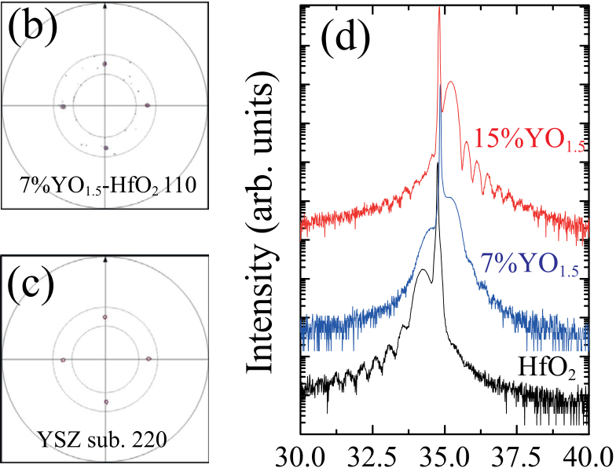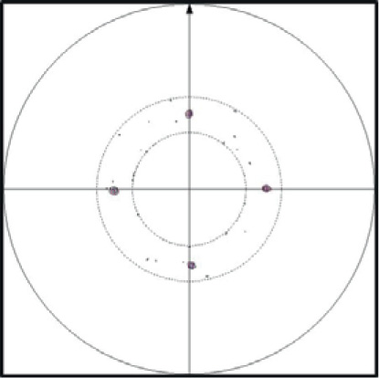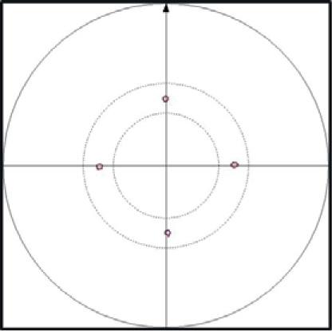

|  |  |  |
| --- | --- | --- |
| 032910-2 | Shimizu et al. | Appl. Phys. Lett. 107, 032910 (2015) |

x ¼ 0.07. The orthorhombic epitaxial film exhibits a struc-tural phase transition to tetragonal phase at significantly high

temperature for device application.

ness were grown by the PLD method. A KrF excimer laser The xYO1.5-(1�x)HfO2 thin films of about 20-nm thick-

with a wavelength of 246 and fluence of 3 mJ/cm2was

employed. A (100)-oriented YSZ single crystal was

employed as a substrate for the growth of the epitaxial films.

YO1.5-substituted HfO2 ceramic targets with various YO1.5

compositions are prepared by the standard solid-state reac-

tion from HfO2 and Y2O3 powders. The substrate tempera-

ture and atmosphere were maintained at 700�C and 1.33 Pa

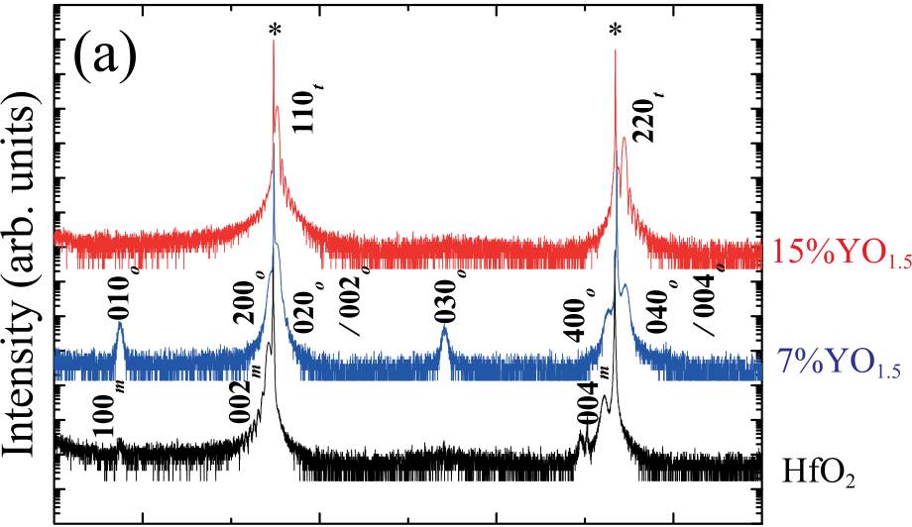

|  |  |  |  |
| --- | --- | --- | --- |
|  |  |  |  |

|  |  |
| --- | --- |
| O2 during the deposition.  The h-2h XRD patterns were measured by a high- |  |

resolution diffractometer (SmartLab, Rigaku). In order to   
determine constituent phases, a wide-area reciprocal space   
mapping measurement (WRSM) was performed by XRD   
equipment (D8-discover, Bruker) with a large area 2-  
dimensional detector (VANTEC-500) under sample-rotation   
conditions. In addition, high-temperature XRD was observed   
with a temperature-controllable sample stage (DHS-1100,   
Anton Paar). Structure analysis was conducted using an   
aberration-corrected annular bright-field scanning transmis-  
sion electron microscopy (ABF-STEM) (JEM-ARM200F   
Cold FEG, JEOL) to visualize the crystalline structure in   
atomic resolution including oxygen atoms. The images were

|  |  |
| --- | --- |
| observed under the condition as follows: the accelerating voltage was 200 kV, the convergent semi-angle a 20 mrad, |  |

and the collection semi-angle b 11–22 mrad. For STEM observations, thin foils were fabricated using a conventional mechanical polishing and Ar ion milling methods (PIPS model 691 and PIPS II model 695, Gatan). The multislice simulation was conducted using a commercial software in order to simulate ABF-STEM images (xHREM, HREM

FIG. 1. (a) h-2h XRD patterns measured for xYO1.5-(1�x)HfO2 films with x ¼ 0, 0.07, and 0.15. Results of the X-ray pole figure measurement for (b) 111 diffraction of 0.07YO1.5-0.93HfO2 film and (c) 220 diffraction from the

YSZ substrate. (d) Enlarged h-2h XRD patterns for the angle range between

30�and 40�.

Research). conventional h-2h XRD measurement is not suitable for col-

Figure 1(a) shows h-2h XRD patterns measured on xYO1.5–(1�x)HfO2 films with x values of 0, 0.07, and 0.15. The {h00} peaks that imply epitaxial growth of the film, including h00, 0k0, and 00l peaks of each symmetry phase, were observed in their XRD patterns. Epitaxial growth was ensured by the X-ray pole figure measurements shown Figs. 1(b) and 1(c). The enlarged XRD patterns for around 200 diffractions of substrates are shown in Fig. 1(d). As shown in this figure, the peak from xYO1.5-(1�x)HfO2 films were located at the lower angle of substrate one for x ¼ 0. On the other hand, peaks from the film could be observed at both of the lower and higher angles for x ¼ 0.07, suggesting that the 0.07YO1.5-0.93HfO2 films have multi orientation or multi phases. Further increase in the x value causes the peak to disappear at the lower angle, and only a peak located at the higher angle appears. In addition, {100} and {300} dif-fraction peaks, which are attributed to super-lattice diffrac-tion of the parent cubic or tetragonal fluorite structure, can be observed for x ¼ 0 and 0.07, whereas no such peaks exist for x ¼ 0.15. These XRD pattern measurements suggest that the crystal symmetry of xYO1.5-(1�x)HfO2 films changes with the substitution amount of YO1.5, as with bulk or poly-crystalline films.5,17,18However, conventional h-2h XRD measurement enables us to obtain only the information from the lattice plane parallel to the substrate surface. Thus, the

lecting enough Bragg diffraction to determine crystal sym-metry, especially for epitaxial films.

To clarify crystal symmetry and the orientations of the films, information from a wider reciprocal space is required. The WRSM was collected by h-2h measurement for various inclination angles with sample rotation, as shown in Figs. 2(a) and 2(b). Details of the measurement are found elsewhere.19 Figures 2(c), 2(d), and 2(e) show the schematics of the simu-lated WRSMs for conceivable symmetry of monoclinic, orthorhombic, and tetragonal phases, respectively, for {100} out-of-plane oriented films grown on (100)YSZ substrates. These figures give the obvious difference in the WRSMs to identify the symmetry of the films. As indicated in these fig-ures, the monoclinic phase shows a very different pattern from the other two phases. The WRSM of the monoclinic phase has a lot of super-spots due to its low symmetry. In par-ticular, the {111} spot splits into two spots with different lat-tice spacing values (d values); this split might be a strong evidence of the existence of the monoclinic phase. On the other hand, only subtle changes are perceived in WRSMs of the orthorhombic and tetragonal phases due to their similar lattice parameters. In addition, their lattice parameters are also similar to the YSZ substrate, resulting in the finding that the main spots of the phases tend to overlap the strong spots from the substrate. One of the noticeable differences in the WRSMs

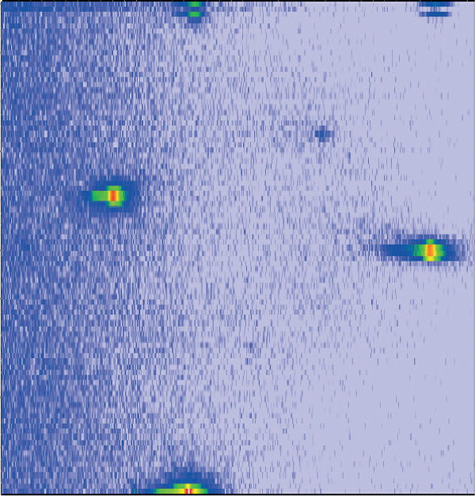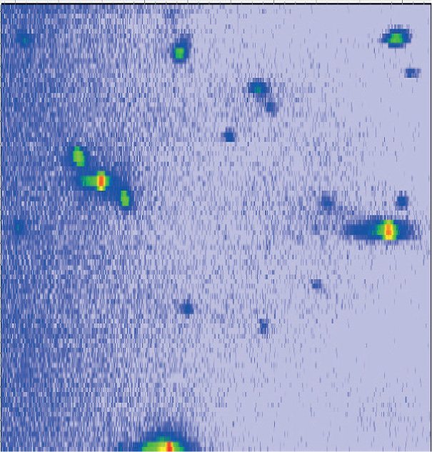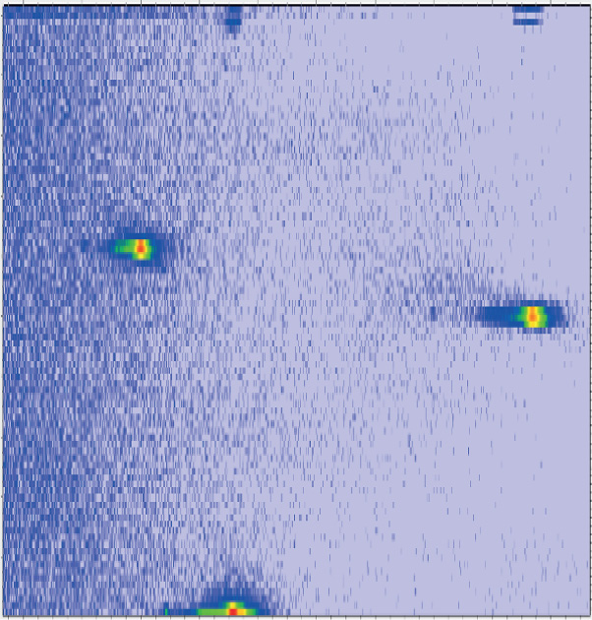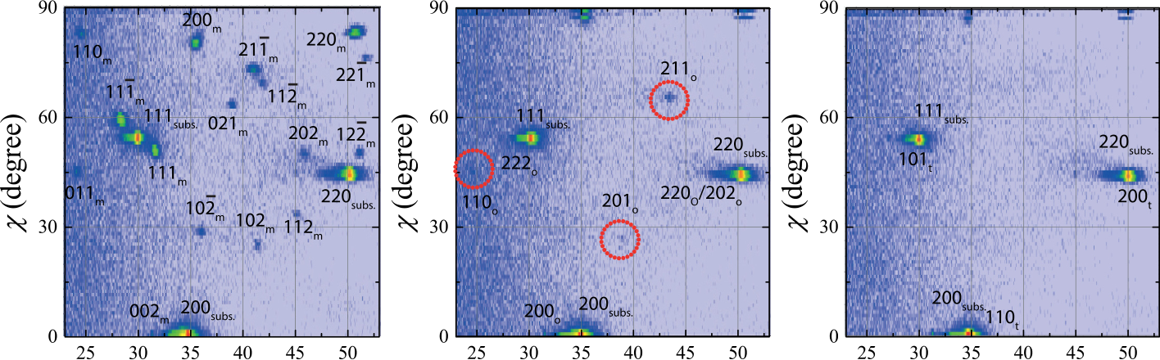

|  |  |  |
| --- | --- | --- |
| 032910-3 | Shimizu et al. | Appl. Phys. Lett. 107, 032910 (2015) |

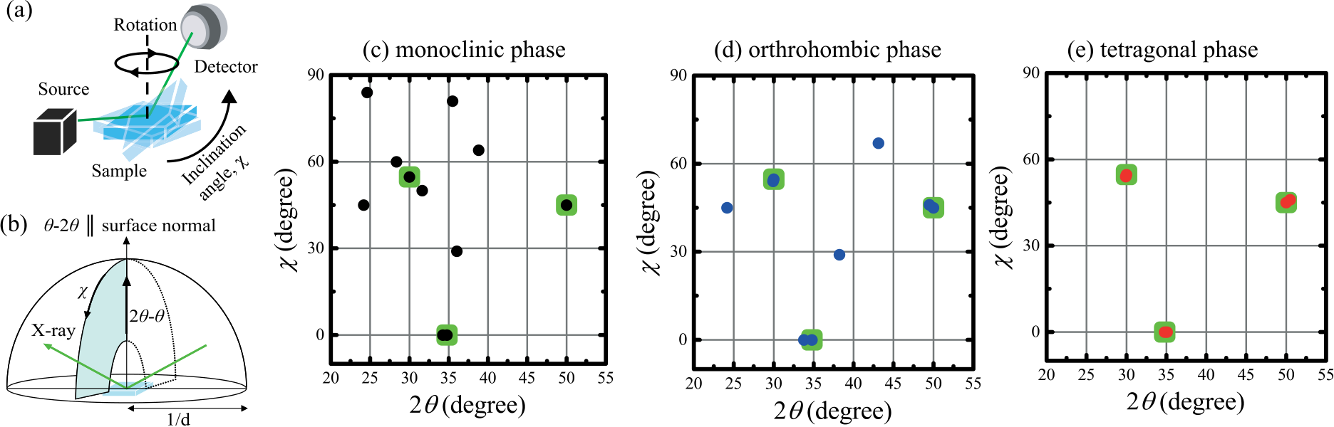

FIG. 2. Schematic diagrams of WRSM measurement of (a) sample and measurement setup and (b) measured reciprocal space. Simulated WRSMs for (c) mono-

clinic, (d) orthorhombic, and (e) tetragonal epitaxial films with {100} out-of-plane orientation grown on cubic (100) YSZ substrates. The circle spots come

from the film, while the square spots originate from the substrate.

of the orthorhombic with tetragonal phases is the appearance of super-spots. There are three super-spots in the WRSM of the orthorhombic phase as shown in Fig. 2(d), while there is

agrees with the appearance of super-spots in h-2h measure-ment shown in Fig. 1 for 0 and 0.07 YO1.5-HfO2 films, which are considered to be monoclinic and orthorhombic phases,

only main spot near the substrate in WRSM of the tetragonal respectively.

phases as shown in Fig. 2(e). Hence, the existence of super-spots is one of the useful probes to distinguish the orthorhom-bic phase from the tetragonal phase.

Figure 3 shows the WRSM measured on films grown from targets with various x values. The obvious split of {111} peak into 111 and 1–11 peaks as well as lots of super-spots appear in the WRSM of the film with x ¼ 0 shown in Fig. 3(a), corresponding to the feature of the WRSM of the monoclinic phase as shown in Fig. 2(c). This suggests that the pure HfO2 epitaxial film (x ¼ 0) has a stable monoclinic structure as observed for powder and polycrystalline films. On the other hand, only weak super-spots were observed for 0.07YO1.5-0.93HfO2 film in addition to the main spots, which are located near the strong spots from the substrate. Although the h-2h pattern [Fig. 1(a)] is similar to that of the pure HfO2 films, the 111 peak does not split for 0.07YO1.5-0.93HfO2 film. The observed WRSM is in accordance with the simulated diagram for the orthorhombic phase schema-tized in Fig. 2(d), and strongly indicates the growth of the orthorhombic HfO2-based epitaxial film. Finally, the WRSM obtained from 0.15YO1.5-0.85HfO2 film shows only main-spots near the spots from the substrate as shown in Fig. 3(c), suggesting that this film has high symmetry such as that pro-duced by a tetragonal or cubic phase structure. This is also in accordance with the previous study on powder and polycrys-talline films. Note that this phase identification from Fig. 3

Combining phase identification and XRD h-2h patterns in Fig. 1, we estimate lattice parameters of the c-axis of monoclinic HfO2 film, a-axis of orthorhombic 0.07YO1.5-HfO2 film, b-or/and c-axes of orthorhombic 0.07YO1.5-HfO2 film, and a-axis of tetragonal 0.15YO1.5-HfO2 film to be 0.5297, 0.5202, 0.5088, and 0.3602 nm, respectively. The lattice parameters of monoclinic phase were calculated by using 99.2�of b angle. These values were slightly different from the previously reported values.18,20This difference may stem from the different compositions or/and deforma-tions by epitaxial strain. Unfortunately, the distinction between b- and c-axes cannot be achieved at present. This means that the lattice parameters of b- and c-axes have a very similar value. Further invesitgation of crystal structure including domain structure is needed.

The WRSM measurement on the series of the YO1.5-sub-stituted HfO2 films clarified the crystal symmetry as a func-tion of x. The phases of the film changed with x from the lower-symmetry phase with a monoclinic structure to a higher-symmetry phase with a tetragonal or cubic structures through an orthorhombic phase. This result is in contrast to the equilibrium phase diagram of HfO2-YO1.5 systems stud-ied on powder samples. In that diagram, the coexistence of monoclinic and cubic phases is most stable below 1000�C for YO1.5 concentrations above 0.03.17On the other hand, single-phase solid solutions were formed in the present

|  |  |  |
| --- | --- | --- |
|  |  |  |

FIG. 3. Measured WRSMs for epitaxial

|  |  |  |  |  |
| --- | --- | --- | --- | --- |
| (a) | pure | HfO2, | (b) | 0.07YO1.5- |
| 0.93HfO2, | | and | (c) | 0.15YO1.5- |

0.85HfO2 films grown on (100) YSZ   
substrates. The super-spots from 7%-

HfO2 film are surrounded by dotted   
lines for the help of understanding.

|  |  |  |
| --- | --- | --- |
|  |  |  |

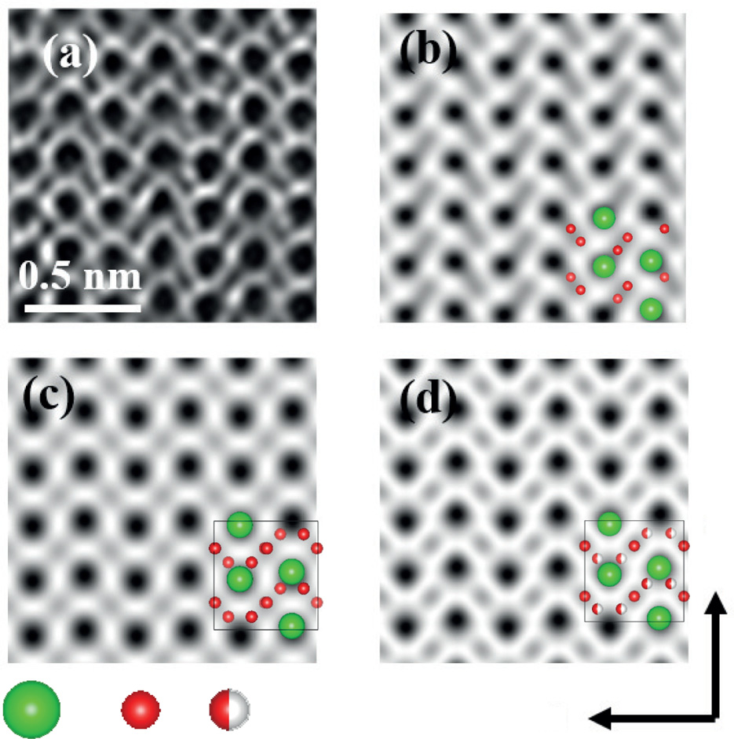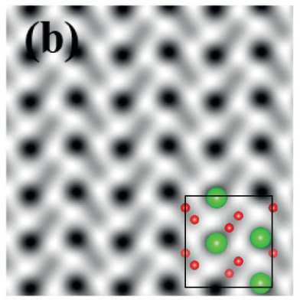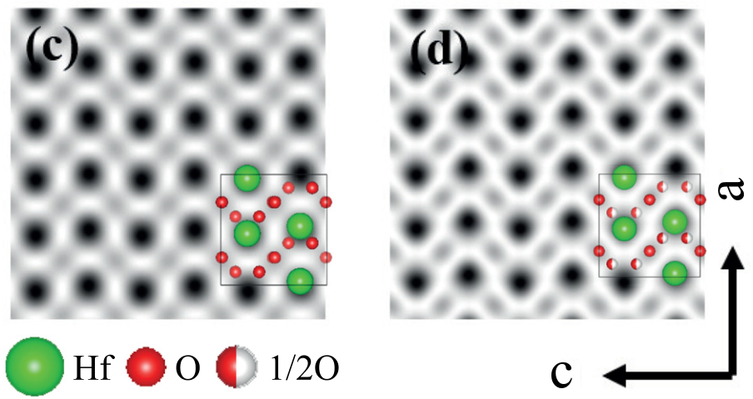

|  |  |  |
| --- | --- | --- |
| 032910-4 | Shimizu et al. | Appl. Phys. Lett. 107, 032910 (2015) |

study, resulting in the growth of the orthorhombic epitaxial   
film on a single-crystal substrate by direct growth from   
vapor. A similarly meta-stable orthorhombic phase in solid   
solution has been achieved in studies of quenched samples   
from molten materials, which are prepared by the arc melting   
of sol-gel derived powders.18These results including the   
present one imply that the formation of a solid solution is   
one of the key factors in obtaining the orthorhombic phase in   
HfO2-related systems. It is worth mentioning that the post-  
crystallization of the amorphous film, by which the ferroelec-  
tric orthorhombic films are obtained, is one way to obtain a   
solid solution. Another possibility to obtain orthorhombic   
phase is due to epitaxial strain. The theoretical calculation   
by Materlik et al. indicates that the epitaxial strain is possible   
to stabilize ferroelectric orthorhombic phase.21   
 In order to elucidate that the orthorhombic film in this   
study is ferroelectric orthrohombic phase, we performed   
ABF-STEM imaging. The ABF-STEM imaging has advan-  
tages to observe light element compared to other STEM ob-  
servation, like HAADF-STEM. Our observed ABF-STEM

image and multislice simulation for considerable three ortho-rhombic phases are shown Fig. 4. Black spots indicate haf-nium atomic columns while grey spots indicate the oxygen atomic columns. The tail like grey contrast of two oxygen atomic columns, which is a characteristic pattern consistent to the polar structure along c-axis, can be observed for the observed ABF-STEM image and simulation for the Pca21 structure, whereas spot like light grey contrast located at cen-ter of for black area (hafnium column) are observed in simu-lation for the Pbcm and Pbca structure, which have inversion center. These results suggest that the present orthorhombic epitaxial film has polar structure, implying the possibility to exhibit ferroelectricity. However, further investigation is needed to clarify the ferroelectricity in epitaxial films.

The structural phase transition provides strong evidence of ferroelectricity because most polar materials with switchable polarization show a phase transition from high-symmetry para-electric to low-symmetry ferroelectric phases with decreasing temperature. Fortunately, 110 diffraction can be observed in the orthorhombic phase, which is considered to be a ferroelec-tric phase, while such diffraction is not seen in the tetragonal phase, which is expected to be paraelectric. Therefore, 110 dif-fraction is a useful probe for detecting this phase transition. Figure 5(a) shows the XRD pattern with inclination angle of 45�measured at various temperatures for 0.07YO1.5-0.93HfO2 film, which has an orthorhombic phase at room temperature as shown in Fig. 3(b). In addition to the strong peak around the 2h angle of 50�, the weak 110 peak at around 24.5�can be observed in the pattern measured at room temperature. Note that the peaks at around 29�and 47�, which are marked by star symbols in the figure, came from the carbon dome of the mea-surement set-up. The intensity of the 110 peak decreased with the increase in temperature, and disappeared above 500�C. Figure 5(b) summarizes the 110 peak intensity as a function of

FIG. 4. (a) ABF-STEM image observed for 0.07YO1.5-HfO2 epitaxial film. Simulated ABF-STEM images for (b) polar Pca21, (c) non-polar Pbca, and (d) Pbcm with the corresponding column arrangement of Hf and O arrangements.

significantly higher than the reported maximum temperature of 200�C, where ferroelectricity has been confirmed by polar-ization-electric-field (P – E) hysteresis measurement.23This

implies that the ferroelectric phase transition temperature is

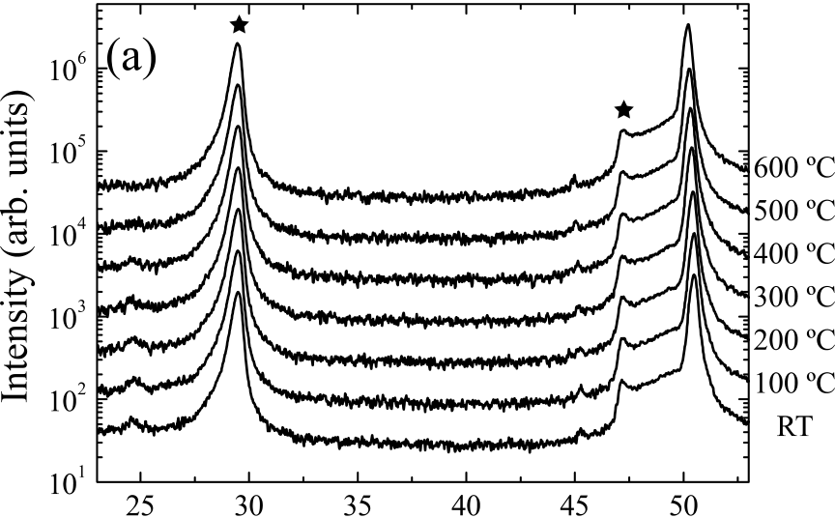



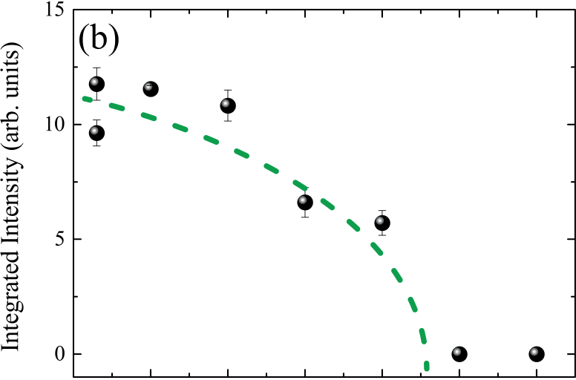

|  |  |  |  |  |  |  |  |
| --- | --- | --- | --- | --- | --- | --- | --- |
| temperature. A parabolic curve of intensity against temperature |  |  |  |  |  |  |  |

was observed; similar temperature-dependent behaviors are often found through structural phase transitions.22Thus, Fig. 5(b) strongly suggests a phase transition from tetragonal to orthorhombic. From the figure, the phase-transition tempera-ture can be estimated at around 450�C. This temperature is



FIG. 5. (a) The XRD patterns with inclination angle of 45�observed for 0.07YO1.5-0.93HfO2 film measured from room temperature to 600�C. (b) The integrated intensity of the 110 super-spot of 0.07YO1.5-0.93HfO2 film as a function of temperature.

|  |  |  |
| --- | --- | --- |
| 032910-5 | Shimizu et al. | Appl. Phys. Lett. 107, 032910 (2015) |

sufficiently high for HfO2-based ferroelectric materials to be used in stable device operation and processing as this tempera-ture is comparable to those of other conventional ferroelectric materials such as Pb(Zr,Ti)O3 and SrBi2Ta2O9.24,25The pres-ent results help to clarify the nature of ferroelectricity in HfO2-based ferroelectric materials and also its potential application to various devices.

epitaxial films with various systems, directly crystallized In summary, we grew xYO1.5-(1�x)HfO2 solid-solution

onto YSZ substrates from the vapor phase by employing the PLD method. The WRSM measurements revealed a constitu-ent phase change from low-symmetry monoclinic to high-symmetry tetragonal or cubic phase with the increase in YO1.5 amount. In addition, the orthorhombic phase, which is expected to exhibit ferroelectricity, was found for x ¼ 0.07. An orthorhombic-to-tetragonal structural phase transition above 450�C was confirmed by high-temperature XRD mea-surement. The present results help to clarify the nature of fer-roelectricity in HfO2-based ferroelectric materials and also its potential application in various devices.

This work was partially funded by the MEXT Elements Strategy Initiative to Form Core Research Center, JSPS KAKENHI Grant No. 25889024 and MEXT KAKENHI Grant No. 26106509. A part of this work was also supported by the Center for Integrated Nanotechnology Support at Tohoku University and Nanotechnology Network Project of the MEXT of the Japanese Government.

1T. S. B€oscke, J. M€uller, D. Br€auhaus, U. Schr€oder, and U. B€ottger, [Appl. Phys. Lett.](http://dx.doi.org/10.1063/1.3634052) 99, 102903 (2011).

2M. H. Park, H. J. Kim, Y. J. Kim, T. Moon, K. Do Kim, and C. S. Hwang, [Adv. Energy Mater.](http://dx.doi.org/10.1002/aenm.201400610) 4, 1400610 (2014).

3M. H. Park, Y. H. Lee, H. J. Kim, Y. J. Kim, T. Moon, K. Do Kim, J. M€uller, A. Kersch, U. Schroeder, T. Mikolajick, and C. S. Hwang, [Adv. Mater.](http://dx.doi.org/10.1002/adma.201404531) 27, 1811 (2015).

4J. Muller, P. Polakowski, S. Mueller, and T. Mikolajick, [ECS J. Solid State Sci. Technol.](http://dx.doi.org/10.1149/2.0081505jss) 4, N30 (2015).

5J. M€uller, U. Schr€oder, T. S. B€oscke, I. M€uller, U. B€ottger, L. Wilde, J. Sundqvist, M. Lemberger, P. K€ucher, T. Mikolajick, and L. Frey, [J. Appl. Phys.](http://dx.doi.org/10.1063/1.3667205) 110, 114113 (2011).

6S. Mueller, J. Mueller, A. Singh, S. Riedel, J. Sundqvist, U. Schroeder, and T. Mikolajick, [Adv. Funct. Mater.](http://dx.doi.org/10.1002/adfm.201103119) 22, 2412 (2012).

7J. M€uller, T. S. B€oscke, U. Schr€oder, S. Mueller, D. Br€auhaus, U. B€ottger, L. Frey, and T. Mikolajick, [Nano Lett.](http://dx.doi.org/10.1021/nl302049k) 12, 4318 (2012).

8T. Schenk, S. Mueller, U. Schroeder, R. Materlik, A. Kersch, M. Popovici, C. Adelmann, S. Van Elshocht, and T. Mikolajick, 2013 Proceedings of the European Solid-State Device Research Conference (ESSDERC) (IEEE, 2013), p. 260.

9U. Schroeder, E. Yurchuk, J. M€uller, D. Martin, T. Schenk, P. Polakowski, C. Adelmann, M. I. Popovici, S. V. Kalinin, and T. Mikolajick, [Jpn. J. Appl. Phys., Part 2](http://dx.doi.org/10.7567/JJAP.53.08LE02) 53, 08LE02 (2014).

10X. Sang, E. D. Grimley, T. Schenk, U. Schroeder, and J. M. LeBeau, [Appl.](http://dx.doi.org/10.1063/1.4919135)  [Phys. Lett.](http://dx.doi.org/10.1063/1.4919135) 106, 162905 (2015).

11S. K. Streiffer, J. A. Eastman, D. D. Fong, C. Thompson, A. Munkholm, M. V. Ramana Murty, O. Auciello, G. R. Bai, and G. B. Stephenson, [Phys. Rev. Lett.](http://dx.doi.org/10.1103/PhysRevLett.89.067601) 89, 67601 (2002).

12C. H. Ahn, K. M. Rabe, and J.-M. Triscone, [Science](http://dx.doi.org/10.1126/science.1092508) 303, 488 (2004). 13D. D. Fong, G. B. Stephenson, S. K. Streiffer, J. A. Eastman, O. Auciello, P. H. Fuoss, and C. Thompson, [Science](http://dx.doi.org/10.1126/science.1098252) 304, 1650 (2004).

14Y. H. Chu, Q. Zhan, L. W. Martin, M. P. Cruz, P. L. Yang, G. W. Pabst, F. Zavaliche, S. Y. Yang, J. X. Zhang, L. Q. Chen, D. G. Schlom, I. N. Lin, T. B. Wu, and R. Ramesh, [Adv. Mater.](http://dx.doi.org/10.1002/adma.200601098) 18, 2307 (2006).

15T. Olsen, U. Schr€oder, S. M€uller, A. Krause, D. Martin, A. Singh, J. M€uller, M. Geidel, and T. Mikolajick, [Appl. Phys. Lett.](http://dx.doi.org/10.1063/1.4747209) 101, 082905 (2012).

16S. Starschich, D. Griesche, T. Schneller, R. Waser, and U. B€ottger, [Appl.](http://dx.doi.org/10.1063/1.4879283)  [Phys. Lett.](http://dx.doi.org/10.1063/1.4879283) 104, 202903 (2014).

17F. M. Spiridonov, L. N. Komissarova, A. G. Kocharov, and V. I. Spitsyn, Russ. J. Inorg. Chem. 14, 1332 (1969).

18M. Yashima, H. Takahashi, K. Ohtake, T. Hirose, M. Kakihana, H. Arashi, Y. Ikuma, Y. Suzuki, and M. Yoshimura, [J. Phys. Chem. Solids](http://dx.doi.org/10.1016/0022-3697(95)00268-5) 57, 289 (1996).

19K. Saito, M. Mitsuya, N. Nukaga, I. Yamaji, T. Akai, and H. Funakubo, [Jpn. J. Appl. Phys., Part 1](http://dx.doi.org/10.1143/JJAP.39.5489) 39, 5489 (2000).

20D. M. Adams, S. Leonard, D. R. Russell, and R. J. Cernik, [J. Phys. Chem.](http://dx.doi.org/10.1016/0022-3697(91)90052-2)  [Solids](http://dx.doi.org/10.1016/0022-3697(91)90052-2) 52, 1181 (1991).

21R. Materlik, C. K€unneth, and A. Kersch, [J. Appl. Phys.](http://dx.doi.org/10.1063/1.4916707) 117, 134109 (2015).

22H. Fujishita and S. Hoshino, [J. Phys. Soc. Jpn.](http://dx.doi.org/10.1143/JPSJ.53.226) 53, 226 (1984).

23S. Mueller, J. M€uller, U. Schroeder, and T. Mikolajick, [IEEE Trans.](http://dx.doi.org/10.1109/TDMR.2012.2216269)  [Device Mater. Reliab.](http://dx.doi.org/10.1109/TDMR.2012.2216269) 13, 93 (2013).

24G. Shirane, K. Suzuki, and A. Takeda, [J. Phys. Soc. Jpn.](http://dx.doi.org/10.1143/JPSJ.7.12) 7, 12 (1952). 25E. C. Subbarao, [J. Phys. Chem. Solids](http://dx.doi.org/10.1016/0022-3697(62)90526-7) 23, 665 (1962).